OS Lab Report – Week 6 & 7

Producer - Consumer Problem

PES1201800366

Aditeya Baral

**1. Week 6**

Write a C Program to simulate race condition in Producer-Consumer Problem.

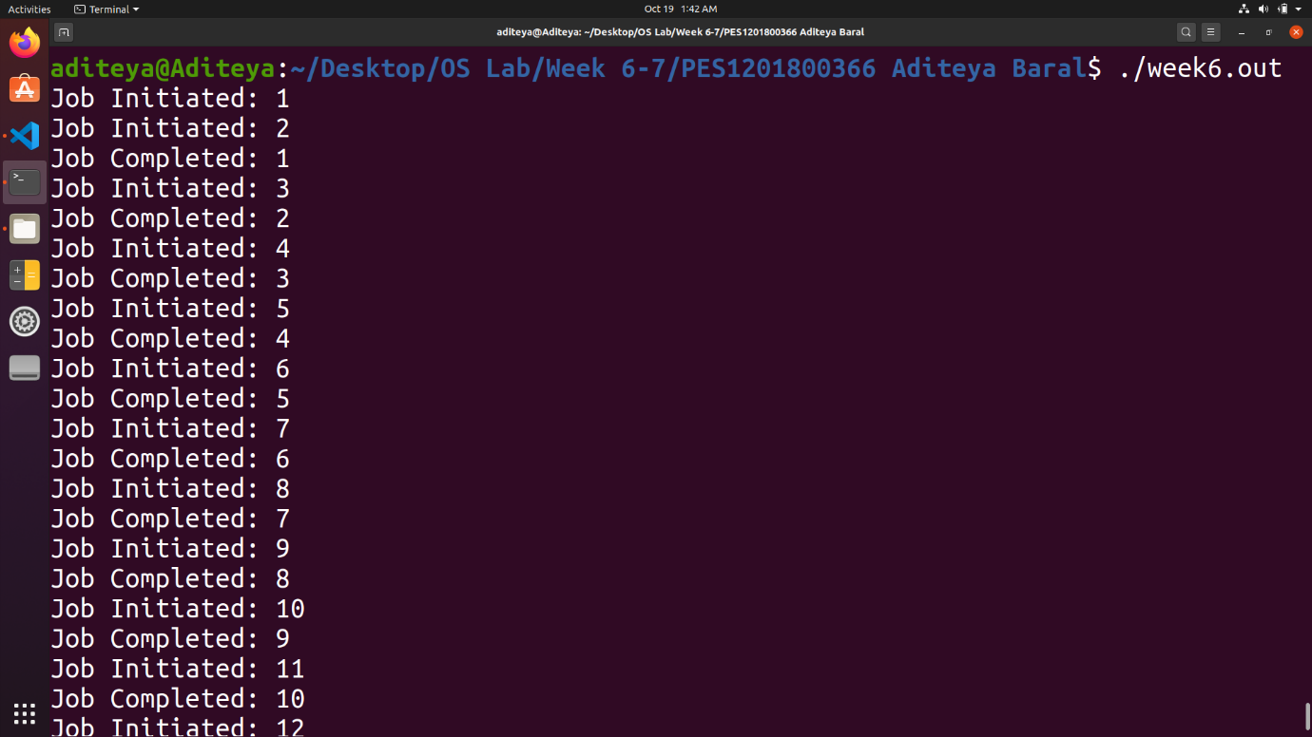

**2. Week 7**

Write a C Program to simulate race condition in Producer-Consumer Problem using Mutex to prevent race condition.